Class Diagram
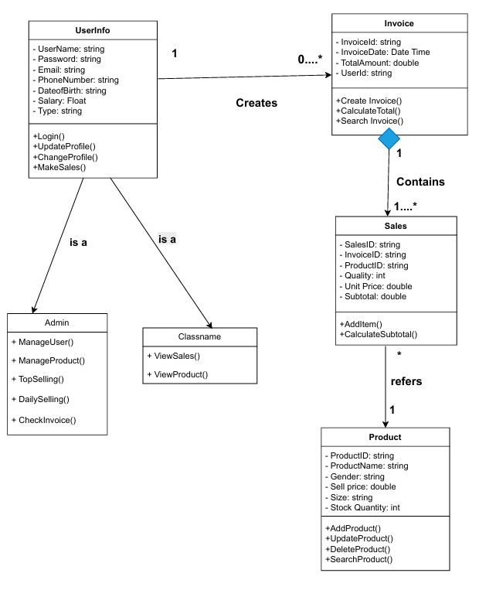
1. UserInfo (Base Class)
• Attributes:
userName: string
password: string
email: string
phoneNumber: string
dateOfBirth: string
salary: float
type: string
• Methods:
login(): void
updateProfile(): void
changeProfile(): void
makeSales(): void
2. Admin (Inherits UserInfo)
• Methods:
manageUser(): void
manageProduct(): void
topSelling(): void
dailySelling(): void
checkInvoice(): void
3. Employee (Inherits UserInfo)
• Methods:
viewSales(): void
viewProduct(): void

4. Invoice
• Attributes:
invoiceId: string
invoiceDate: DateTime
totalAmount: double
userId: string
• Methods:
createInvoice(): void
calculateTotal(): double
searchInvoice(): Invoice
5. Sales
• Attributes:
salesId: string
invoiceId: string
productId: string
quantity: integer
unitPrice: double
subTotal: double
• Methods:
addItem(): void
calculateSubtotal(): double
6. Product
• Attributes:
productId: string
productName: string
gender: string
sellPrice: double
size: string
stockQuantity: integer
• Methods:
addProduct(): void
updateProduct(): void
deleteProduct(): void
searchProduct(): Product
7. Relationships (Implied in Diagram)
• Inheritance:
UserInfo → Admin
UserInfo → Employee
• Associations:
UserInfo creates Invoice
Sales is associated with Product
• Composition:
Invoice contains Sales

